Team Name: Incognito
Team members:

Name: - Rajdeep Pal
Email: - www.rajdeep.gov.in@gmail.com
Name: - Shaunak Ghosh
Email: - shaunak.pritam@gmail.com

- Themes: -
  - UI/UX and Frontend: - Redesign specific features/pages using Next.js / React.js.
  - Encryption: - Proper encryption to provide secured data transfer between vendors and buyers.

- Idea of our Project: -
Our project aims to revamp the RFQ management process for heavy industries by designing an intuitive, efficient, and AI-integrated platform. Our solution provides the following benefits:
1. Automated RFQ Generation: Automatically generate structured RFQs from a Bill of Quantities (BOQ) or predefined templates, reducing manual data entry.
2. Enhanced UI/UX: Responsive design with intuitive dashboards, guided navigation, and dynamic vendor comparison tools.
3. Vendor Analytics: Advanced vendor discovery, their comparison charts and AI based scoring systems to simplify decision making.
4. Data Security: End-to-end encryption for RFQ data exchange.

- Methodology: -
  - Understanding the Problem & Designing:
    - We will start by analysing the current RFQ process to identify pain points and inefficiencies.
    - Using tools like Figma, we will design simple wireframes for essential pages such as RFQ Management, Vendor Comparison, and Magic Search.
  - Building the User Interface:
    - We will develop a responsive, easy-to-navigate website using Next.js/React.js to ensure a smooth user experience.
  - Adding Smart Features with AI:
    - To streamline the RFQ generation, we will integrate AI to automatically extract data from Bill of Quantities (BOQs) and fill in RFQ details.
    - We will also use AI to summarize lengthy tender documents and provide a Q&A feature for users to get quick clarifications.
  - Making it Secure:
    - We will implement strong encryption techniques to protect sensitive buyer and vendor data during interactions.
  - Testing and Launching:
    - We will thoroughly test the solution to ensure everything functions as expected.
    - Once ready, we will deploy the solution on cloud platforms for scalability and reliability.
This approach will allow us to create an efficient, secure, and easy-to-use solution to automate and optimize the RFQ process for heavy industries.

- Wireframe: -
  - Images: -
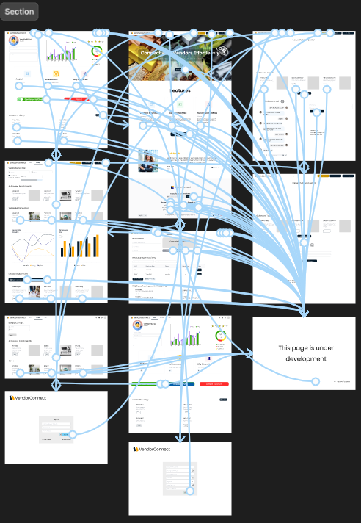
  - Figma Link: - https://www.figma.com/proto/OQ6M7mNVx7ydrn2q4sdqnB/TechTriad?node-id=6-665&p=f&t=aLcT9ZsH4UFezIUc-1&scaling=contain&content-scaling=fixed&page-id=0%3A1

- Flowchart: -
  - Images: -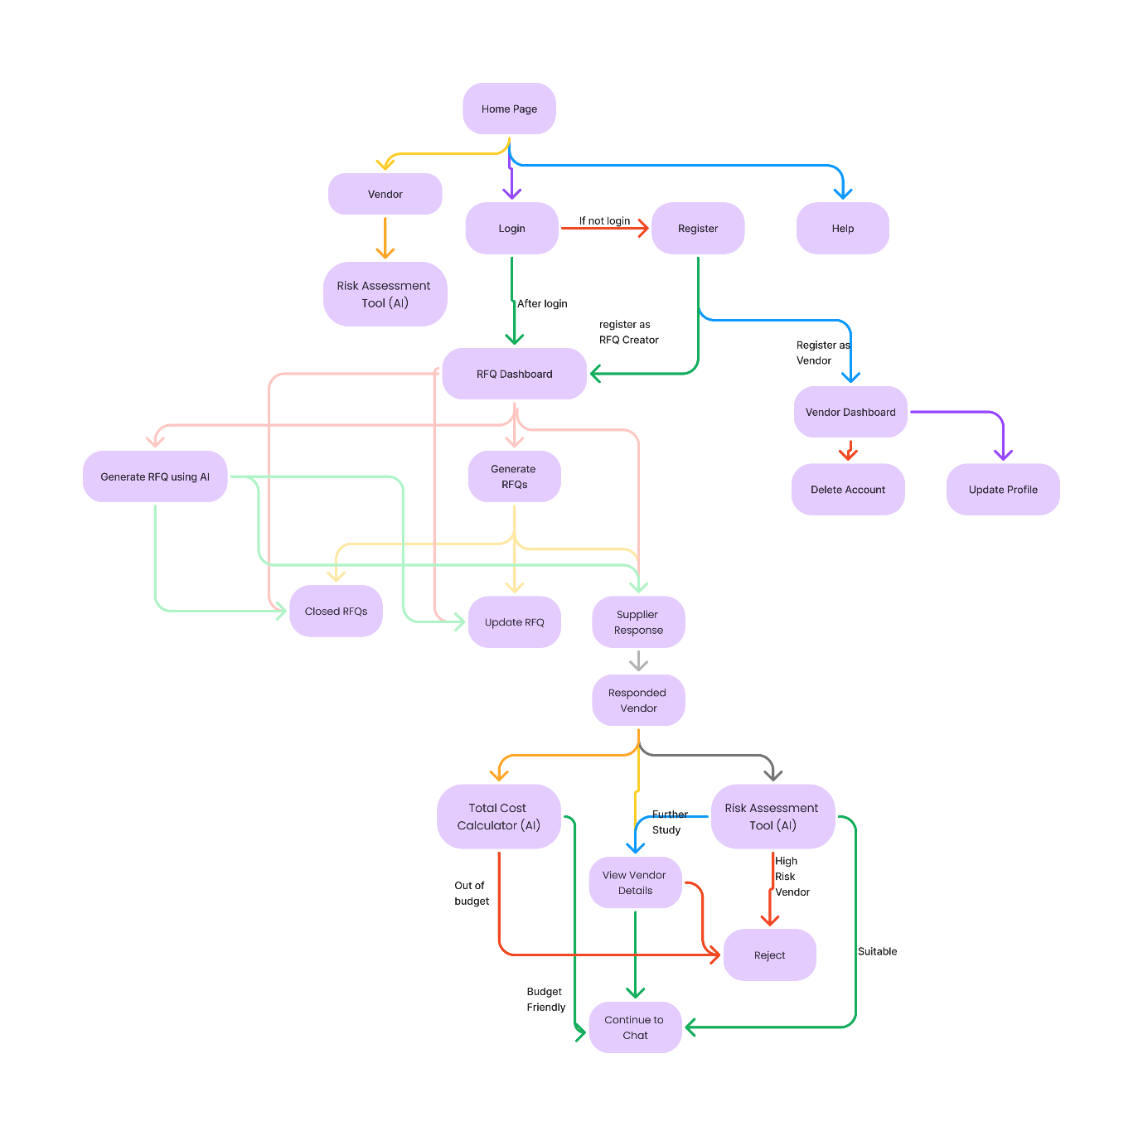
  - Flowchart link: - https://www.figma.com/board/HmbOxjT4fFVYqy2KEMk46k/TechTriad?node-id=0-1&t=v7ivXOmlm9cDomOH-1

- Final Projects: -
  - Frontend Link: - frontend link
  - Backend Link: - Backend link
  - GitHub Link: - Git
  - PPT: - Click Here

